**Name – Akshat Jaiswal**

**Roll No. – 21052646**

**Section – CSE 37**

**DSA LAB 3**

1. **WAP to create a dynamic array and perform the linear search operation.**

**Input:**

#include <stdio.h>

#include <stdlib.h>

*int* main (*void*){

*int* *arr;

*int* n,item,flag=0,pos;

printf("Enter the size of array: ");

scanf("%d",&n);

arr=(*int*\*)malloc(n*sizeof(*int*));

printf("Enter the elements in the array: ");

for (*int* i = 0; i < n; i++)

{

scanf("%d",(arr+i));

}

printf("\nEnter the item you wanna search: ");

scanf("%d",&item);

for (*int* i = 0; i < n; i++)

{

    if(item==*(arr+i)){

    flag=1;

    pos=i;

    }

}

if(flag==1)

printf("\nSearch Successfull!!\nItem in position no. %d ",pos+1);

else

printf("\nSearch not Successfull!!");

return 0;

}

**Output:**

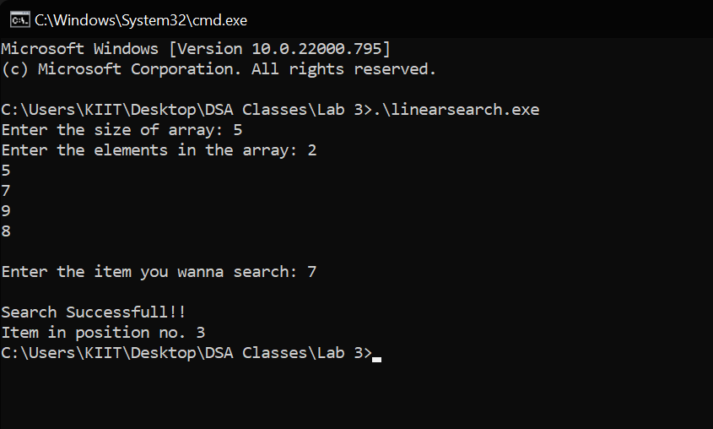

1. **WAP to create a static array and write a sort function for bubble sort.**

**Input:**

#include <stdio.h>

*void* sort();

*int* main (*void*){

*int* arr[100],n;

printf("Enter the size of array: ");

scanf("%d",&n);

printf("Enter the elements in the array: ");

for (*int* i = 0; i < n; i++)

{

scanf("%d",&arr[i]);

}

sort(arr,n);

printf("\nElements after sorting: ");

for (*int* i = 0; i < n; i++)

{

    printf("%d  ",arr[i]);

}

return 0;

}

*void* sort(*int* *arr*[],*int* *n*){

    for (*int* i = 0; i < *n*; i++)

    {

        for (*int* j = i+1; j < *n*; j++)

        {

            if(*arr*[i]>*arr*[j])

            {

*int* temp = *arr*[i];

*arr*[i]=*arr*[j];

*arr*[j]=temp;

            }

        }

    }

}

**Output:**

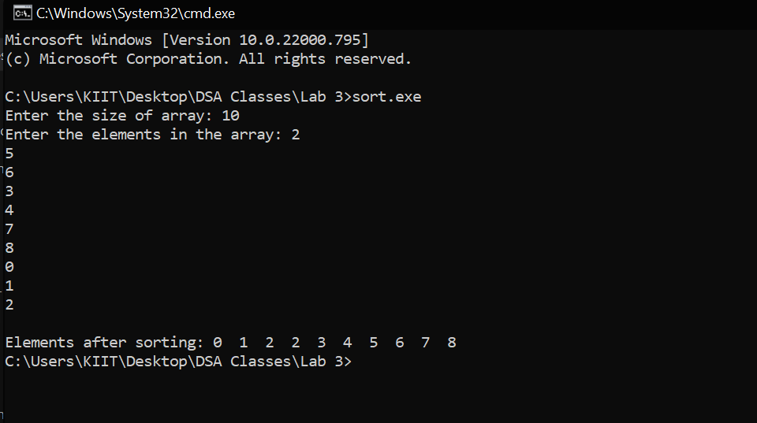

1. **WAP to merge two sorted arrays into one sorted array.**

**Input:**

#include <stdio.h>

*void* merge();

*int* main (*void*){

*int* arr1[100],arr2[100],m,n;

printf("Enter the size of the 1st array: ");

scanf("%d",&m);

printf("Enter the size of the 2nd array: ");

scanf("%d",&n);

printf("Enter the elements in the 1st array: ");

for (*int* i = 0; i < m; i++)

{

scanf("%d",&arr1[i]);

}

printf("Enter the elements in the 2nd array: ");

for (*int* i = 0; i < n; i++)

{

scanf("%d",&arr2[i]);

}

printf("\nElements in the 1st array are: ");

for (*int* i = 0; i < m; i++)

{

    printf("%d  ",arr1[i]);

}

printf("\nElements in the 2nd array are: ");

for (*int* i = 0; i < n; i++)

{

    printf("%d  ",arr2[i]);

}

sort(arr1,m);

sort(arr2,n);

merge(arr1,arr2,m,n);

return 0;

}

*void* merge(*int* *arr1*[] , *int* *arr2*[],*int* *m*,*int* *n*){

*int* arr3[100];

    for (*int* i = 0; i < *m*; i++)

    {

        arr3[i]=*arr1*[i];

    }

    for (*int* i = 0; i < *n*; i++)

    {

        arr3[*m*+i]=*arr2*[i];

    }

    sort(arr3,(*m*+*n*));

    printf("\n\nTHE MERGED ARRAY: \n");

    for (*int* i = 0; i < *m*+*n*; i++)

    {

        printf("%d  ",arr3[i]);

    }

}

*void* sort(*int* *arr*[],*int* *n*){

    for (*int* i = 0; i < *n*; i++)

    {

        for (*int* j = i+1; j < *n*; j++)

        {

            if(*arr*[i]>*arr*[j])

            {

*int* temp = *arr*[i];

*arr*[i]=*arr*[j];

*arr*[j]=temp;

            }

        }

    }

}

**Output:**

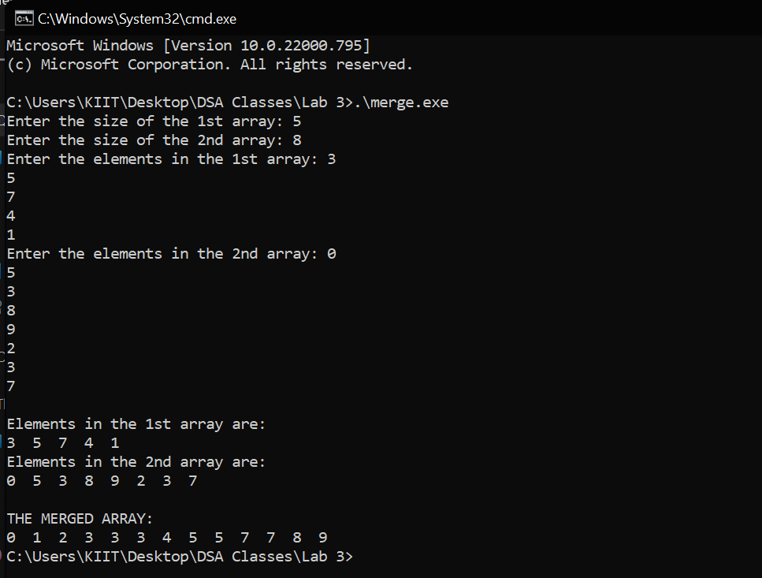

1. **WAP to take an array and reverse the array.**

**Input:**

#include <stdio.h>

*int* main (*void*)

{

*int* arr[100];

*int* i, n, temp=0;

    printf("Enter the size of array: ");

    scanf("%d", &n);

    printf("Input %d elements in the array :\n", n);

    for (i = 0; i < n; i++) {

        printf("arr[%d]: ", i);

        scanf("%d", &arr[i]);

    }

        printf("\nElements in the array are:\n");

    for ( i = 0; i < n; i++)

        printf("%d ",arr[i]);

    for ( i = 0; i <= n/2; i++)

    {

      for (*int* j = n-1-i; j>=0; j--)

      {

        temp=arr[i];

        arr[i]=arr[j];

        arr[j]=temp;

        break;

      }

    }

    printf("\nAfter Reversing:\n");

    for ( i = 0; i < n; i++)

      printf("%d ",arr[i]);

return 0;

}

**Output:**

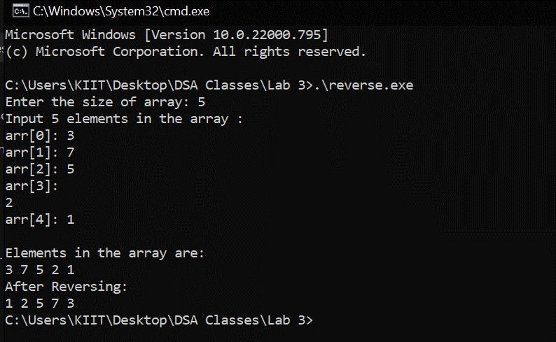

1. **WAP to find the largest element and count the occurrence of the largest element.**

**Input:**

#include <stdio.h>

*int* main (*void*)

{

*int* arr[10];

*int* i, n, max,count=0;

    printf("Enter the size of array: ");

    scanf("%d", &n);

    printf("Input %d elements in the array :\n", n);

    for (i = 0; i < n; i++) {

        printf("arr[%d]: ", i);

        scanf("%d", &arr[i]);

    }

        printf("\nElements in the array are: ");

    for ( i = 0; i < n; i++)

        printf("%d ",arr[i]);

    max=arr[0];

    for (*int* i = 0; i < n; i++)

    {

        if(arr[i]>max)

        max=arr[i];

    }

    for (*int* i = 0; i < n; i++)

    {

        if(max==arr[i])

        count++;

    }

    printf("\nThe Largest Element: %d",max);

    printf("\nThe Number of times it occured: %d",count);

    return 0;

}

**Output:**

